Nielsen's Heuristics - Notes
Multi ways to evaluate
- Empirical
  - Access with real users
- Formal
  - Models and formulas to calculate measures
- Automated
  - Software Measures
When to get a Design Critique?
- Before user testing of software
- Before redesigning of software
- When you know there are problems, but you need evidence
- Before release of software
Heuristic Evaluation
- Developed by Jakob Nielsen
- Helps find usability problems in a design
- Small set (3-5) of evaluators examine Ul
  - independently check for compliance with usability principles ("heuristics")
  - different evaluators will find different problems
  - evaluators only communicate afterwards
    - findings are then aggregated
- Can perform on working Ul or sketches
Nielsen's Ten Heuristics
- Visibility of System Status
- Match between System & World
- User Control & Freedom
- Consistency & Standards
- Error Prevention
- Recognition Rather than Recall
- Flexibility & Efficiency of Use
- Aesthetic & Minimalist Design
- Help Users Recognize, Diagnose, & Recover from Errors
- Help & Documentation

Evaluators' Process
- Step through design several times
  - Examine details, flow, and architecture
  - Consult list of usability principles
  - ..and anything else that comes to mind
- Which principles?
  - Nielsen's "heuristics"
  - Category-specific heuristics from e.g.. design goals, competitive analysis, existing designs
- Use violations to redesign/fix problems
Why Multiple Evaluators?
- No evaluator finds everything
- Some find more than others
- 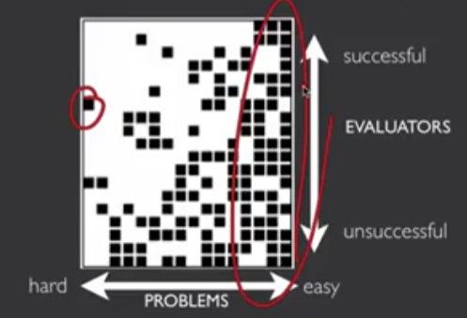
Decreasing Returns
- Caveat: graphs for a specific example
- 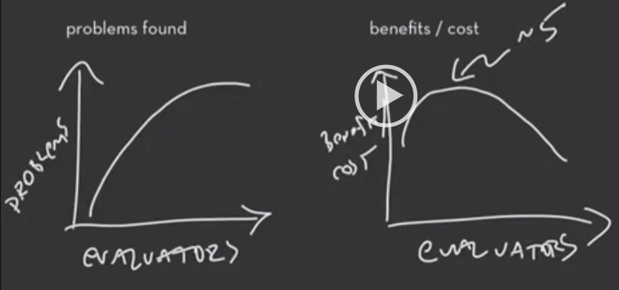
Heuristic Eval: Cost-effective
- In one case: benefit-cost ratio of 48
  - estimated benefit $500.000; coSt $ | 0.500
  - value of each problem ~$ l 5K
  - How might we calculate this value?
    - in-house -> productivity; open market -> sales
- Severe problems found more often
- Single evaluator achieves poor results
  - only finds 35% of usability problems
  - 5 evaluators find ~ 75% of problems
Heuristics vs. User Testing
.Heuristic Evaluation often faster  - 1-2 hours each evaluator  HE results come pre-interpreted | User testing is more accurate (by def.)  - takes into account actual users and tasks  HE may miss problems & find "false  positives"
Valuable to alternate methods
- find different problems
- don't waste participants

Phases of Heuristic Evaluation
- Pre-evaluation training: give evaluators needed domain knowledge and information on the scenario
- Evaluation: individuals evaluate and then aggregate results
- Severity rating: determine how severe each problem is (priority). Can do first individually and then as a group
- Debriefing: review with design team
How-to: Heuristic Evaluation
- At least two passes for each evaluator
  - first to get feel for flow and scope of system
  - second to focus on specific elements
- If system is walk-up-and-use or evaluators are domain experts, no assistance needed
  - otherwise might supply evaluators with scenarios
- Each evaluator produces list of problems
  - explain why with reference to heuristic or other information
  - be specific and list each problem separately
- Why separate listings for each violation?
  - risk of repeating problematic aspect
  - may not be possible to fix all problems
- Where problems may be found
  - single location in Ul
  - two or more locations that need to be compared
  - problem with overall structure of Ul
  - something is missing
    - ambiguous with early prototypes; clarify in advance
    - sometimes features are implied by design docs and just haven‘t been "implemented" — just relax on those

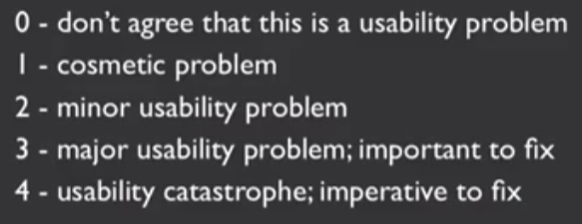
Severity Rating
- Independently estimate after review
- Allocate resources to fix problems
- Estimate need for more usability efforts
- Severity combines
  - frequency
  - impact
  - persistence
Example:
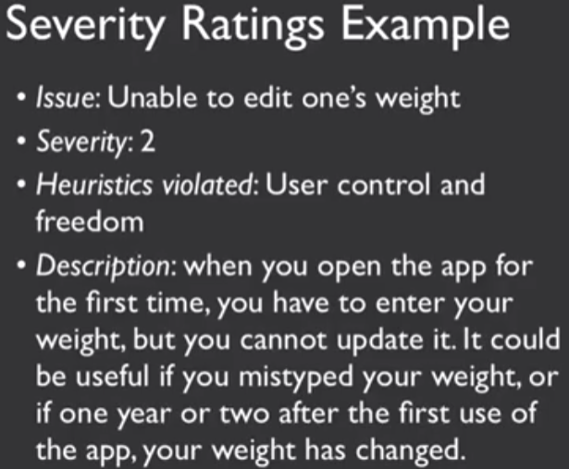
Debriefing
- Conduct with evaluators, observers, and development team members
- Discuss general characteristics of Ul
- Suggest potential improvements to address major usability problems
- Dev. team rates effort to fix
- Brainstorm solutions
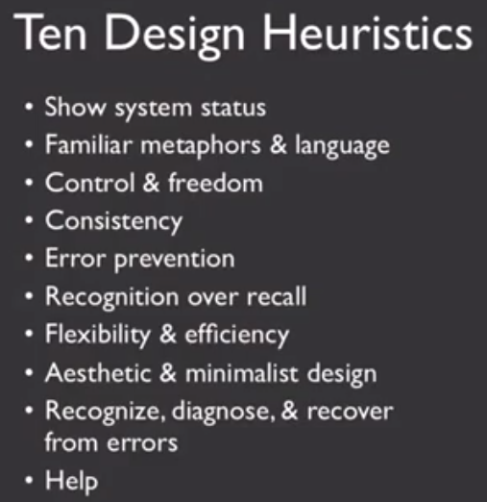
Based on Jakob Nielsen
Show System Status - Provide excellent feedback

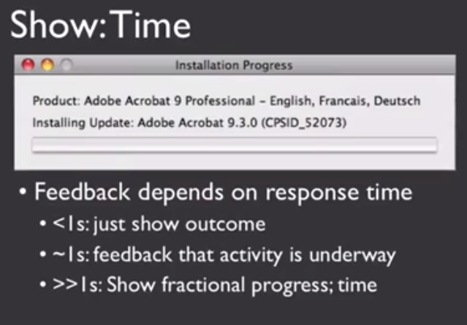
- Show progress of how far along
- How far the system is
- And how far you are

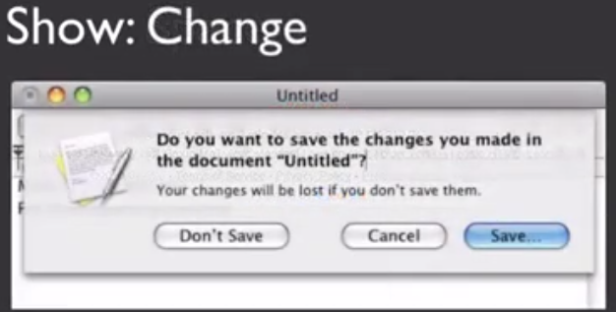
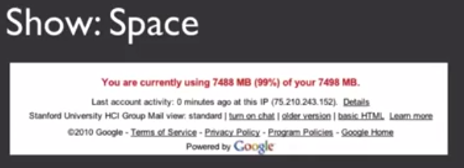
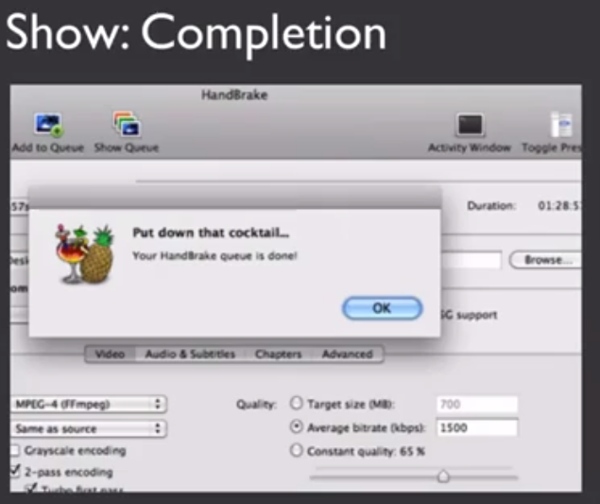
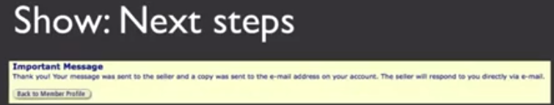
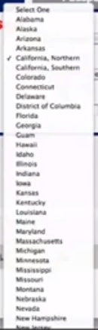

Use Familiar Metaphors
- Like Desktop, trash, folders
Familiar Language
- words most people currently understand what it means
Familiar Category
- Like the US States →→→→→→→→→→→→-→
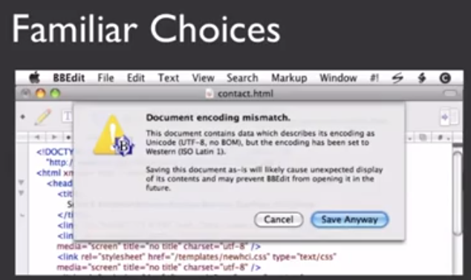
User Control & Freedom
- Appropriate control for user
- Too much control can cause problems
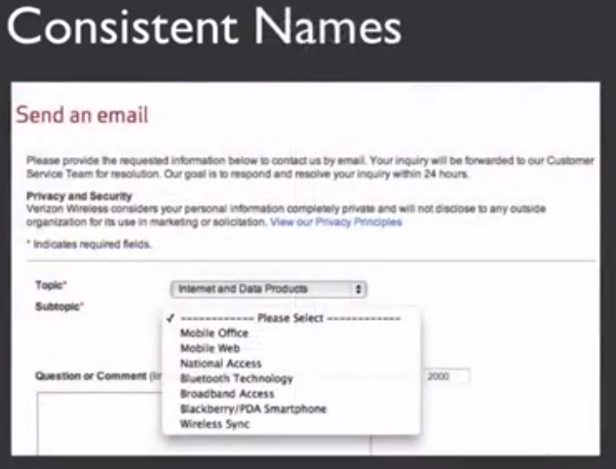
Consistency & Standards
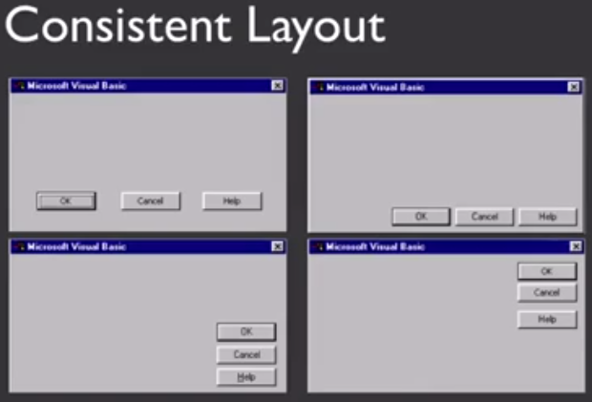

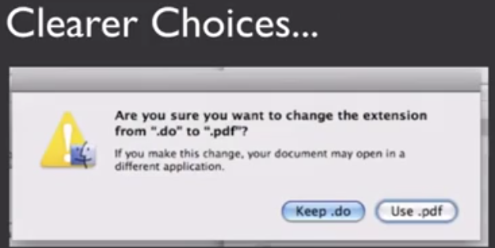
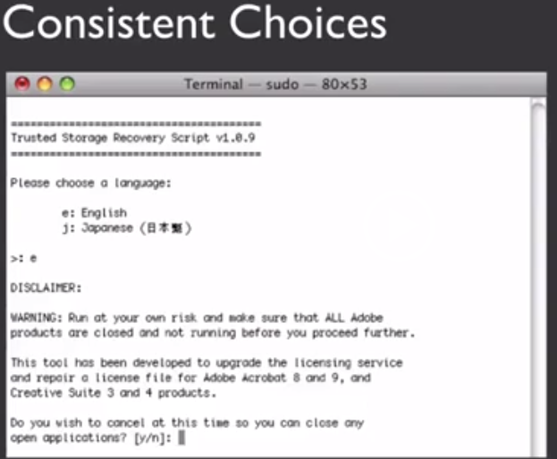

Error Prevention
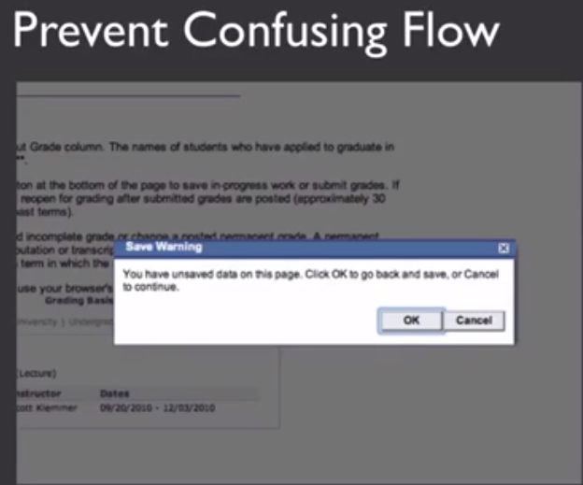
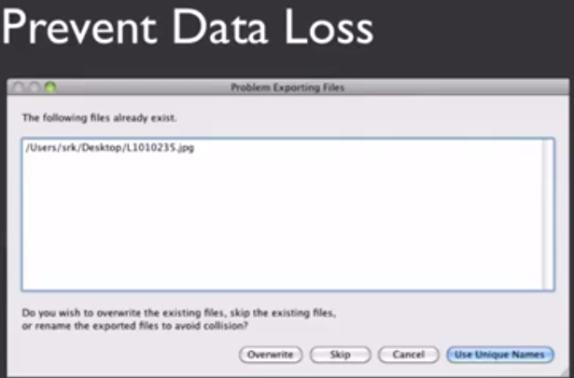
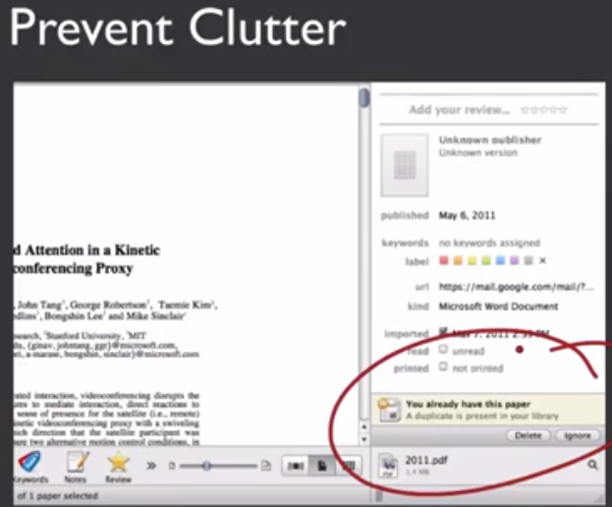
(better feature : would be to allow preview as well)
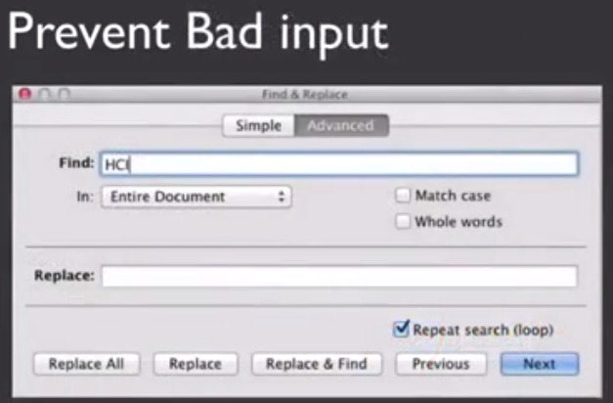

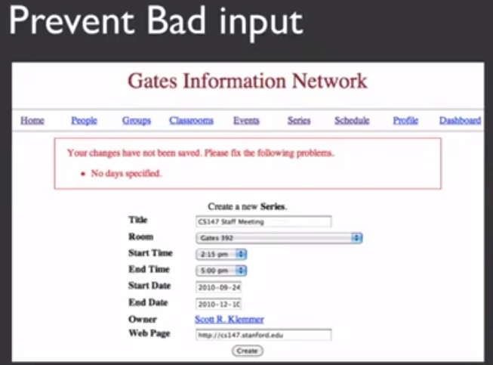
- Recognition
- Flexible
- Minimalism
- Errors

Recognition: Avoid codes
- Hard to read or understand the meaning of labels, and etc..
Recognition: Avoid extra hurdles
- Making complicated layout where users can't tell how to navi
Recognition: Previews
- Showing previews makes easier to see, when you don't want waste time opening
